Downtown Revitalization Public Infrastructure District
Proposal to Serve as Municipal Advisor

Request for Proposals – Municipal Advisor Services

November 2026

Disclaimer
This proposal was prepared exclusively for the benefit of and internal use by the recipient for the purpose of considering the transaction or transactions contemplated herein. Tierra Financial Advisors, LLC (“Tierra Financial Advisors”) acknowledges that this proposal may be subject to public disclosure under the Utah Government Records Access and Management Act and does not claim any portion of it as protected.
By acceptance of these materials, and notwithstanding any other express or implied agreement, arrangement, or understanding to the contrary, Tierra Financial Advisors, its affiliates and the recipient agree that the recipient (and its employees, representatives, and other agents) may disclose to any and all persons, without limitation of any kind from the commencement of discussions, the tax treatment, structure or strategy of the transaction and any fact that may be relevant to understanding such treatment, structure or strategy, and all materials of any kind (including opinions or other tax analyses) that are provided to the recipient relating to such tax treatment, structure, or strategy.
The information and any analyses contained in this presentation are taken from, or based upon, information obtained from the recipient or from publicly available sources, the completeness and accuracy of which has not been independently verified and cannot be assured by Tierra Financial Advisors. The information and any analyses in these materials reflect prevailing conditions and Tierra Financial Advisors’ views as of this date, all of which are subject to change.
To the extent projections and financial analyses are set forth herein, they may be based on estimated financial performance prepared by or in consultation with the recipient and are intended only to suggest reasonable ranges of results. The printed presentation is incomplete without reference to the oral presentation or other written materials that supplement it.
IRS Circular 230 Disclosure: Tierra Financial Advisors and its affiliates do not provide tax advice, and nothing contained herein should be construed as tax advice. Any discussion of U.S. tax matters contained herein (including any attachments) (i) was not intended or written to be used, and cannot be used, by you for the purpose of avoiding tax penalties; and (ii) was written in connection with the promotion or marketing of the matters addressed herein. Accordingly, you should seek advice based upon your particular circumstances from an independent tax advisor.

Disclosures
Tierra Financial Advisors is registered with the Securities and Exchange Commission and the MSRB. The website for the MSRB can be located at: http://www.MSRB.org. On the homepage of the MSRB website there is a link to an investor brochure that describes protections that may be provided by the MSRB Rules and how to file a complaint with an appropriate regulatory authority.
Tierra Financial Advisors serves a wide variety of other clients that may from time to time have interests that could have a direct or indirect impact on the interests of the Client such as seeking to access the new issue market with advantageous timing and with limited competition at the time of the offering. None of these other engagements or relationships would impair Tierra Financial Advisors’ ability to fulfill its regulatory duties to the Client.
Tierra Financial Advisors, LLC is a wholly owned subsidiary of D.R. Horton, Inc. D.R. Horton, Inc. is a publicly traded corporation whose stock is listed on the New York Stock Exchange. D.R. Horton, Inc. also owns a controlling interest in Forestar Group Inc., a residential lot developer. To Tierra’s knowledge, neither D.R. Horton, Inc. nor Forestar Group Inc. is a developer, landowner, or other participant in the Downtown Revitalization Public Infrastructure District or the Project.
From time to time, D.R. Horton, Inc., may engage broker-dealers, commercial banks, and/or other financial institutions while conducting regular business operations. D.R. Horton, Inc. is a national homebuilder that is primarily engaged in the acquisition and development of land and the construction and sale of residential homes. D.R. Horton, Inc. is not registered as a municipal advisor, and therefore does not engage in municipal advisory services.
MSRB Rule G-42 requires that municipal advisors provide to their client’s certain disclosures of legal or disciplinary events material to its client's evaluation of the municipal advisor or the integrity of the municipal advisor's management or advisory personnel.
There are no legal or disciplinary events that Tierra Financial Advisors deems material to the Client's evaluation of Tierra Financial Advisors, or the integrity of Tierra Financial Advisors management or advisory personnel assigned to the Client.
The SEC requires Tierra Financial Advisors as a registered municipal advisor and its individual employees who are registered as municipal advisors to file certain items of information on the SEC's Form MA or MA-I. Tierra Financial Advisors most recent Form MA and each most recent Form MA-I filed with the SEC are available on the SEC's EDGAR system.
Tierra Financial Advisors has not made any material legal or disciplinary event disclosures on Form MA or any Form MA-I filed with the SEC.

Cover Letter
[November 10, 2026]
Downtown Revitalization Public Infrastructure District
c/o Gilmore & Bell, P.C., General Counsel to the District
Attn: Randall Larsen, Aaron Wade and Adam Daly
Submitted electronically in PDF format
Dear Mr. Larsen, Mr. Wade and Mr. Daly:
Tierra Financial Advisors, LLC ("Tierra") is pleased to submit this proposal to serve as Municipal Advisor to the Downtown Revitalization Public Infrastructure District (the "District"). Tierra confirms that serving the District presents no conflicts of interest.
Understanding the District. The District's June 2025 financing – $869.4 million across three liens – committed the City's 0.5% Revitalization Sales Tax to the Delta Center and SEG redevelopment. On September 24, the Board discussed about $680 million of Salt Palace proceeds in 2027, supported by the County's "fourth quarter" and the City's "5th 5th" transportation sales tax shares, which 2025 legislation lets be redirected to the District; the Board opened accounts for the 5th-5th revenues in December 2025. Tierra's model for the District shows these, with the Revitalization Sales Tax surplus, support about $680 million only if debt service rises with revenue – so structure and growth assumptions will decide whether that amount is achievable. With collections ahead of every 2025 projection, the District approaches this financing from strength.
Development Finance Specialists. Since November 2023, Tierra has served as municipal advisor or structuring advisor on 94 bond issues totaling $1.43 billion – every one for a development project – including rated, insured, nonrated and directly placed transactions secured by sales tax, tax increment and other revenues pledged by a separate public entity. In Utah we advise public infrastructure districts in Salem City and Heber City and are working on other development district projects throughout the state.

Creative Solutions Driven by Technical Capabilities. Tierra’s advisors work hard to solve their clients’ most challenging financing situations. Tailormade dynamic cashflow and financing models are built to each client’s individual needs. Bespoke models support independent, client-focused advice by aligning closely with each client’s unique circumstances and minimizing external influence. This is important for the City as Tierra performs its own analysis rather than simply endorsing recommendations from third parties, which allows it to maintain independence in all aspects of advisory work. Our recommendations are grounded in data-driven modeling, comprehensive market research, and a clear understanding of each client’s financial objectives.

Independent, Fiduciary Advice. Tierra provides only municipal advisory services. We have no broker-dealer affiliation, trading desk or investor clients. We build our own cash flow and sizing models rather than relying on the underwriter's, which lets us negotiate structure, pricing and fees from a position of knowledge.
Local Presence. Tierra maintains office space in Utah at 4100 N. Horton Way, Suite 300, Lehi. Tierra's parent, D.R. Horton, has been in Utah for 26 years and has 196 employees in the state.
We would welcome the opportunity to help the District deliver the Salt Palace and the completion of the downtown entertainment district. As Managing Director and Principal of Tierra, I am authorized to contractually bind the firm. Thank you for your consideration.

Sincerely,
  Evan D. Kist, CFA, Managing Director and Principal  Tierra Financial Advisors, LLC | Amanda Salome, Director  Tierra Financial Advisors, LLC

Table of Contents
Cover Letter 3
Response to Section IV – Proposal Submission Requirements
A. Confirmation of Minimum Qualifications 5
B. Description of the Advisor 5
C. Business Philosophy and Utah Marketplace Strengths 6
D. Project Understanding and Suggested Financing Plan 6
E. Team Serving the District 10
F. Utah Sales Tax and Tax Increment Transactions 10
G. Utah Tax Increment Transactions 11
H. Approach to the Scope of Work 11
I. References 12
J. Fee Schedule 12
Appendices
Appendix A – Resumes 13
Appendix B – Bond Issues Advised Since November 2023 15
Appendix C – Credit Data and Charts 18
Appendix D – Series 2027 Preliminary Cash Flows 22
Proposal – Municipal Advisor Services

A. Confirmation of Minimum Qualifications
Tierra confirms that it can provide every service described in Section III of the RFP. Our status against each minimum qualification is set out below.
Minimum Qualification | Tierra Response
Utah sales tax and tax increment bonds > $50 million (past 5 years) | No – exception requested.* [Is a municipal advisor who strictly provides a pricing certificate on a $50mm financing more qualified or knowledge than a municipal advisor that actually prices and structures bond financings, regardless of size. Consensus would say no]
Utah development bonds > $50 million (past 5 years) | No – exception requested.† Tierra advises three Utah development districts with total bond programs exceeding $50 million, however, their public market transactions to date are less than $50 million.
Registered with the MSRB and SEC as a municipal advisor | Yes. SEC File No. 867-02487 / MSRB ID K1264.
No major regulatory censure or SEC/MSRB action in the last ten years | Confirmed. Tierra has made no legal or disciplinary disclosures on Form MA or any Form MA-I. An SEC examination covering an 18-month lookback identified no material findings as of April 1, 2026.
Insurance requirement (Section VIII.H) | [Tierra meets all the insurance requirements. Please see ___ for that information}.
Registration with the Utah Division of Corporations (Section VIII.D) | [Tierra's Utah foreign LLC registration is currently being reviewed by Utah’s Division of Corporation and Commercial Code.]
*Exception to the first minimum qualification. At a prior firm, outside the five-year window, Mr. Kist was on a team that served as senior manager to the Utah Transit Authority on a $50 million subordinate sales tax revenue bond financing. Beyond UTA, Tierra's finance professionals, while at prior broker-dealer firms, served as senior managing underwriters for more than $2.5 billion of sales tax or tax increment bond financings.
Tierra is very familiar with Utah tax increments through our coverage of the Utah Inland Port Authority, which finances its project areas with tax differential (tax increment) revenues; UIPA shortlisted Tierra for municipal advisor in 2025, and Tierra finished second in the selection process. Additionally, Tierra serves as municipal advisor to many Colorado metropolitan districts, where urban renewal authorities use tax increment as their primary funding tool and pledge a portion to the overlapping development district bond financings.
[Tierra’s experience in Texas will serve the district well. We have vast experience working on development district deals that utilize Chapter 380/381 which are tax increment municipal and county agreements (called “TIRZ”) in Texas. Most recently (November 2026), Tierra served as municipal advisor on a $177 million development bond financing for a Texas issuer supported in part by a municipality's TIRZ revenues – a pledge requiring the municipality's consent and an interlocal agreement.
†Exception to the second minimum qualification. Tierra currently serves as municipal advisor to three Utah development districts on bond programs in excess of $50 million. However, the public market transactions executed to date under those programs are less than $50 million. Tierra specializes in municipal advisory services for special district finance. It is important to note that over the last five years, Tierra has advised on 122 development district bond transactions for a total par amount of $1.7 billion. We believe we are qualified to serve the district and knowledgeably advise the Board.

B. Description of the Advisor
Add lead in paragraph about Tierra
Ownership. Tierra Financial Advisors, LLC was established in October 2019 and is a wholly owned subsidiary of D.R. Horton, Inc. (NYSE: DHI). Tierra operates independently and only provides municipal advisory services. Tierra is dedicated to serving land use authorities, development districts, and municipal partners
Volume of business. Establishd in October 2019, Tierra has served as municipal advisor on ___ development district transactions for a total par amount of $___ billion. We serve as municipal advisor to 45 different development districts in Utah, Colorado, Texas and Arizona. A complete list is in Appendix B.
Utah presence. Tierra maintains office space in Utah at 4100 N. Horton Way, Suite 300, Lehi, Utah 84048. Tierra's parent, D.R. Horton, Inc., has been in business in Utah for 26 years and currently has 196 employees in the state.

C. Business Philosophy and Utah Marketplace Strengths
Tierra views its role as municipal advisor to the Authority to be an on-going responsibility that requires active engagement. As the Authority’s municipal advisor, our primary objective is to be viewed as an extension of your staff. We look forward to serving the Authority by drawing on our in-depth knowledge of municipal markets and vast client coverage experience. Over their careers, Tierra’s municipal advisors have experience working with nearly every type of municipal client including cities, counties, development districts, infrastructure, transportation, state-level agencies, utilities, tribal governments, hospitals, and special situation borrowers. Tierra has leadership qualities, experiences, and capabilities that distinguish us from other municipal advisors.
Please see Appendix [D] for the resumes of our experienced team members.
Municipal Experience & Relevant Attributes of the Authority’s Team
- Specialize in serving as municipal advisor to special districts (UT PID experience) and land use clients  - Extensive knowledge of general municipal finance  - Collaborative advisor with a service-orientated approach  - Experience with complex, multiphase projects  - Proven track record of providing clients with innovative ideas and solutions  - Superior technical abilities (as it relates to cash flow modeling and bond structuring)  - Sustainability/Energy conservation project finance experience | - Methodical in reviewing legal and relevant deal-related documentation  - Lead solicitation and selection process for underwriter(s)  - Extensive experience in long-term strategic financial planning  - Thorough understanding of public finance laws  - Passionate problem-solvers and creative thinkers  - Knowledge and experience with a wide variety of debt structures, products, credits, and funding mechanisms including all that are contemplated by the Authority  - Leadership in the marketing and pricing of municipal securities

D. Project Understanding and Suggested Financing Plan
While not officially involved in the Project, we are very familiar with the 2025 financing structure, its revenue sources and their historical collection rates (see Appendix), viable alternative financing structures, the rating implications of different structures and the district’s desire to pursue a 2027 financing. While the specifics for the 2027 financing are limited, Tierra has still been able to create a bespoke cashflow model for the 2027 financing utilizing our extensive development district finance experience. [claude make a strong explanation why we know everything list out all items, 2025 debt structure, legislation, tax collection history, indentures, budgest, meeting minutes, etc.] While this proposal from the district is for future municipal advisory services related to a contemplated 2027 financing, we believe it is extremely important to understand the Series 2025 transaction, its structure and flow of funds. Lets start be reviewing the 2025 financing because this helps inform our ability to structure the 2027 financing.
The District and its 2025 Financing
Topic | Key Facts
District | Created by Salt Lake City on April 8, 2025 as a convention center public infrastructure district. Five-member Board appointed by the City Council (three SEG, one City, one County representative). About 10 acres today, with an annexation area of about 46 acres that includes the north half of the Convention Center block.
2025 Bonds | $649,895,000 Series 2025A First Lien (A1 underlying), $194,460,000 Series 2025B Second Lien (A3 underlying), both insured by Assured Guaranty, and $25,000,000 Series 2025C Subordinate cash flow bonds (unrated). Final maturities 2055 (A/B) and 2035 (C).
Pledged revenue | City's 0.5% Revitalization Sales Tax (Utah Code 59-12-402.5), January 2025 through December 2054, net of a 1% City administrative fee and capped District administrative expenses. Imposed at the statutory maximum rate.
Lien status and coverage | First and second liens closed to new money (refunding parity only); $900 million proceeds cap fully used. 2025 OS senior coverage begins at 111% (base case); the reduced-growth case falls to 100% in 2036.
Budget and performance | Revitalization Sales Tax of $45.8 million in 2025 (partial year), $55.9 million projected for 2026 and $57.0 million budgeted for 2027. On 2026 projections, senior debt service of $51.6 million is covered about 1.08x (Tierra calculation). The 2025C Bonds are being redeemed early from surplus revenue (Tierra interpretation from district budget): $5.5 million in 2026, with the remaining $19.5 million budgeted for 2027. Capital outlay is budgeted at $350 million for 2027; the construction fund held $622 million at September 30, 2026.
Collections vs. 2025 projections | The District's EMMA monthly reports, which tie to the Utah State Tax Commission's distributions, show $56.5 million for calendar 2025 sales – 0.9% above the Official Statement base case ($56.0 million) and 1.9% above the reduced-growth case. January–August 2026 is up 4.5% on 2025, more than double the 2.0% the base case assumed, and trailing-12-month collections of $58.1 million already exceed the base case for all of 2026 ($57.1 million). On that trend, senior coverage for the bond year ending June 1, 2027 is about 1.15x versus 1.12x projected (Tierra calculation). The FYE 2025 annual report and audit were posted September 9, 2026, ahead of the September 30 deadline.
The Salt Palace, the Reinvestment Zone and the County
Topic | Key Facts
Legislation | S.B. 26 (2025) authorized a convention center public infrastructure district and a convention center reinvestment zone. A district within or adjacent to the zone may issue bonds for convention revitalization projects, and the County Mayor approves expenditures of zone revenue (Utah Code 17D-4-202.1, 17D-4-203). S.B. 39 (2026) recodified the investment zone statutes
The zone | Approved by the State's Housing and Transit Reinvestment Zone Committee on April 4, 2025: about 50 acres, including the Salt Palace, Abravanel Hall, UMOCA and Block 67. Reported capture of local sales tax increment, part of the State sales tax increment and 100% of new property tax for about 30 years. *Need confirmation on capture percentages and base year value against the statute and the approved zone proposal.*
Project cost | About $1.8 billion of zone projects: roughly $1.28 billion for the Salt Palace (including a second ballroom), about $229 million for Abravanel Hall, UMOCA and the east plaza, and Block 67 parking.
Salt Palace schedule | County in Phase II design (April 2026). Jacobsen Construction / AECOM Hunt (construction), MHTN and Populous (architects), Legends Global (operator). Western portion sold to SEG ($55.4 million), with transfer expected in February 2027. Closes fall 2027 for about three years; completion targeted for 2031.
County funding | The County's 2026 budget includes a Salt Palace Renovation Project fund ($48.1 million beginning balance), $4.1 million of Salt Palace debt service transfers, and a $150 million Visitor and Promotion Fund sales tax revenue bond in its financing plans.
Series 2027 plan | The plan dates to May 2025, when the County's trustee said the County intended to "monetize the full amount for the Salt Palace project" and to assign transportation taxes to the District. At the September 24, 2026 meeting, the Board discussed a Series 2027 ("Series D") issue by the District for the Salt Palace renovation: interlocal agreements would bring "the city's fifth" and "the county's fourth quarter" revenues into the District to bolster the Revitalization Sales Tax, with anticipated construction proceeds of about $680 million.
New revenue sources | County share of the 4th quarter (Utah Code 59-12-2219): 0.25% countywide transportation tax; the County's 0.05% share was $19.4 million in 2024, and a first-class county may transfer it to a convention center PID. City share of the 5th 5th (59-12-2220): 0.20% countywide tax effective July 2025; the capital city must transfer at least 50% (up to 100%) of its share – about $4.8 million in the first year – to the PID for the bondable term. In December 2025 the Board opened accounts to receive 5th-5th revenues. Salt Lake City's combined 8.45% rate is otherwise at its statutory maximum. *Need confirmation on the to be pledged.*
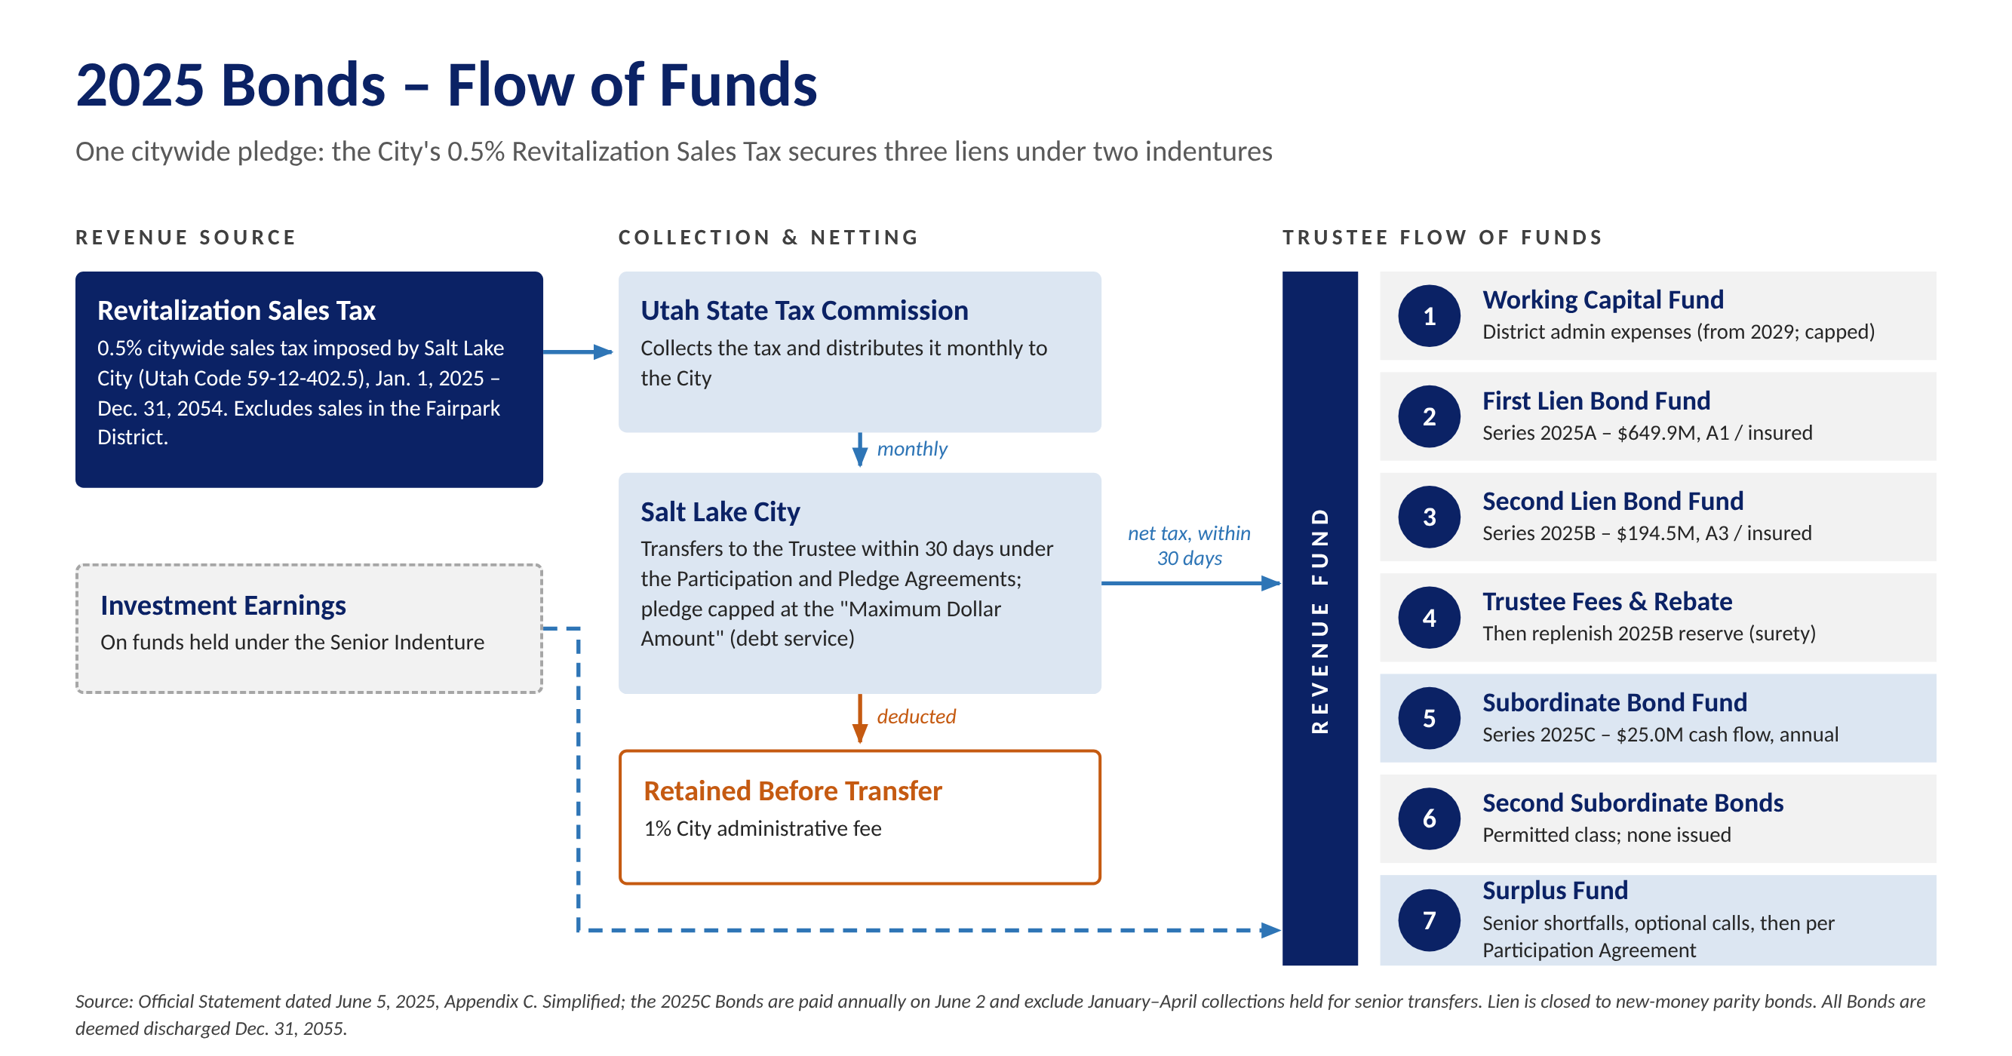
Figure 1: 2025 Bonds flow of funds (simplified from the Official Statement)
Charts of actual collections against the 2025 projections, coverage and Series 2027 sizing are in Appendix C.
What This Means for the 2027 Bonds
- Fitting beside the 2025 liens. The first and second liens are closed to new money, and the 2025 indenture permits Second Subordinate Bonds only once no Subordinate Bonds are outstanding. The District's 2027 budget shows the remaining $19.5 million of 2025C Bonds paid down with cash; they are also callable at par from January 15, 2027, so refunding them as part of the Series 2027 issue is another possibility. The Series 2027 Bonds could take a junior lien on the Revitalization Sales Tax together with a first lien on the new City and County revenues, or sit under a separate indenture with the sales tax surplus as secondary support. Both must be tested with counsel against the Participation Agreement ($900 million cap and Maximum Dollar Amount) and the statutory limits on the tax.
- How revenue would flow. We expect a new indenture for the Series 2027 Bonds that ties into the 2025 waterfall. The County's 4th-quarter share and the City's 5th-5th share would go to the Series 2027 trustee with a first lien. The Revitalization Sales Tax would still pay the 2025A and 2025B Bonds first; what remains would go the Series 2027 Bonds through the 2025 indenture's subordinate position, if the 2025C Bonds are refunded, or its Second Subordinate position, if they are paid down with cash – not through the Surplus Fund, which is released under the Participation Agreement. The 2027 indenture would then fund debt service, a reserve [do you mean DSRF?] and a rate stabilization fund before any release (Figure C-5).
- Interlocal agreements are the credit documents. Each must be irrevocable for the life of the bonds, define the revenue and its priority against the City's and County's other obligations, include non-impairment and additional bonds covenants, and route revenue directly to the trustee. The County must commit its 4th-quarter share for the full term, and the City's 5th-5th transfer must run for the bondable term; both depend on countywide taxes the County could change, which investors will scrutinize.
- Variability in Rates. This was a mentioned concern of the Board from the [Claude which meeting?]. For perspective, holding debt service constant, each 50 basis point rise in rates reduces proceeds by about $45 million under a rising structure. We would be happy to share a more detailed funding analysis with the Board upon request.
- The County is a partner. The County owns and will rebuild the Salt Palace and is already budgeting Salt Palace debt service and its own $150 million Visitor and Promotion Fund bonds.
- Managing the 2025 proceeds. The 2025 construction fund earned about $21.6 million of interest through September 30, 2026. We will track yield restriction and rebate with counsel and capture positive arbitrage where permitted.
Alternative Structures and Rating Implications
Structure | When It Fits | Rating / Market Implication
Combined pledge: junior lien on the Revitalization Sales Tax plus first lien on the County 4th-quarter and City 5th-5th shares | After the 2025C Bonds are retired – paid down with cash, as the 2027 budget shows, or called and refunded into the Series 2027 issue – if the 2025 documents and Participation Agreement allow | Broadest security; rating rests mainly on the new revenues; insurance possible as in 2025
Separate indenture on the County and City transportation-tax shares, with sales tax surplus as secondary support | If the 2025 documents limit junior liens, or a cleaner credit is preferred | Rated on the new revenues alone; simpler for investors to analyze
Phased issuance or draw-down placement | Draws extend over several years (Salt Palace closes fall 2027; completion targeted for 2031) | Reduces negative arbitrage and capitalized interest; later series priced on actual collections
Interim notes refunded with long-term bonds | New revenues have little history at first issuance | Bank or short-term market until a rating can be supported
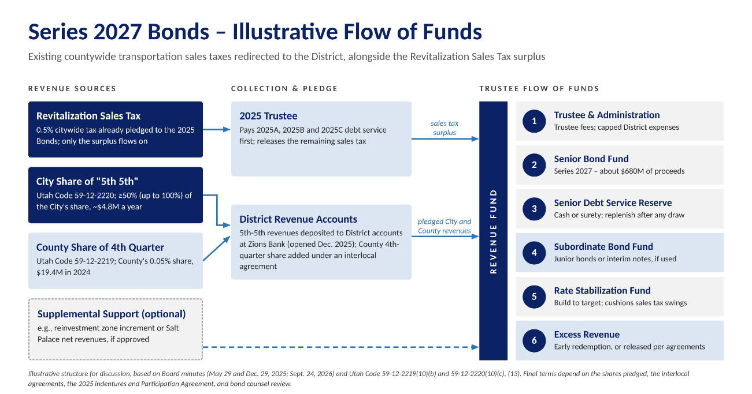
Rating agencies will focus on the breadth of the countywide County and City shares, the irrevocability of each pledge, coverage at maximum annual debt service and the additional bonds test. [The task in 2027 is to extend the confidence behind the 2025 A1 and A3 ratings to the new revenues without diluting the existing liens.Claude how will it dilute the existing liens?]

Figure 2: Series 2027 Bonds – illustrative flow of funds{move under graphic]
Tierra's Series 2027 Model
Tierra has built a proprietary cash flow model for the District that sets the 2025 bonds and a Series 2027 issue side by side, year by year through 2054: the Revitalization Sales Tax under the 2025 Official Statement's three cases; 2025A, 2025B and 2025C debt service and coverage; the County 4th-quarter and City 5th-5th shares under a first lien; and the sales tax left after the 2025 bonds under a junior lien, all growing at the Revitalization Sales Tax rate. At 1.25x coverage and a 5.5% yield, the identified revenues – about $32 million in 2028 – support about $678 million of proceeds if debt service rises with revenue, essentially the $680 million discussed, but about $353 million with level debt service. The rising structure leans on sales tax growth: the County and City shares alone cover only 0.56x of 2054 debt service, and under the Official Statement's reduced-growth case capacity falls to about $353 million (Appendix C-3 and C-4). The model is built and ready, so Tierra can hit the ground running – testing pledges, structures, rates and timing with the District, counsel and the County from the first week.
Illustrative Sources and Uses (base case) | Level Debt Service | Rising Debt Service
Sources: Series 2027 Bonds (par) | $358.1 million | $688.2 million
Uses: Project (construction) fund | $352.8 million | $677.9 million
Uses: Costs of issuance (1.5%) | $5.4 million | $10.3 million
Debt service, 2028 / maximum | $25.8M / $25.8M | $25.8M / $113.1M
Tierra estimate; 1.25x coverage, 5.5% yield, final maturity 2054, 100% of the County and City shares pledged; no reserve fund, capitalized interest or 2025C refunding.
Suggested Financing Plan
Timing | Key Activities
Nov 2026 – Feb 2027 | Review the 2025 indentures, Participation Agreement and S.B. 26 for lien capacity; confirm the County 4th-quarter and City 5th-5th shares to be pledged and their collection history; build an integrated model of the 2025 and Series 2027 credits; identify legal and tax questions for counsel.
Feb – May 2027 | Recommend security, lien structure, sizing, timing and method of sale; present options to the Board; negotiate interlocal pledge terms with the City, County and State.
Apr – Jul 2027 | Run underwriter selection; develop rating and insurance strategy; draft documents.
Second half 2027 | Rating presentations, investor outreach, pricing and closing of the first series ahead of the Salt Palace closure in fall 2027; evaluate later series against the County's draw schedule.

E. Team Serving the District
Evan Kist, CFA, will be the lead advisor. All Tierra advisors report directly to Mr. Kist, and the full team works on every transaction so knowledge is shared and coverage is continuous. Detailed resumes are in Appendix A.
Team Member | Responsibilities | Experience and Education
Evan Kist, CFA  Managing Director & Principal  Lead Advisor  Series 50 & 54 | Overall strategy and credit structuring; negotiations with the City, County, State and underwriters; leads pricing; presents to the Board; supervises all work product and compliance. | Started Tierra in September 2019. More than 20 years in municipal finance, including 10 years at Merrill Lynch (New York and Chicago). BA Economics, University of New Mexico (Phi Beta Kappa); CFA charterholder.
Amanda Salome  Director  Day-to-Day Advisor  Series 50 | Document review, due diligence, POS/OS coordination, financing schedules, procurement of underwriters and other professionals, continuing disclosure support. | With Tierra since 2025.removing highlight More than 15 years in investment and commercial banking, including J.P. Morgan and Merrill Lynch. BA Economics and Geographical Studies, University of Chicago.
Chris Prugar  Managing Director  Day-to-Day Advisor  Series 50 | Cash flow and sizing models, coverage and stress testing, rating agency and investor materials, refunding analysis, transaction execution. | With Tierra since April 2022. More than 16 years in public finance, including BofA Securities. BS Business Administration, Washington and Lee University (cum laude).

F. Utah Sales Tax and Tax Increment Transactions
Currently, Tierra is working on many tax increment financing deals throughout Texas and in other parts of the country. Negotiations regarding developments and potential incentives take many years to get finalized. Please see our response to Question A above regarding further details on our experience with tax increment financings.
[Mention Colorado financings with URA such Liberty Ranch, St. Vrain Lakes, Timberleaf, etc.] and evan’s past experience in NM with gross receipts tax bonds (essentially sales tax revenue bonds). Talk about the increments in NM and how they are the same as Utah. Evan covered large cities and counties which allocated increments exactly like this transaction. Mention prior deal experience with transportation issuers, etc. sales tax revenue bonds.
Mention Chris’s experience with Louisville (find the case study in the documents uploaded)

G. Utah Tax Increment Transactions
[EVAN TO REVIEW] Tierra has not yet advised on a Utah tax increment bond issue. Outside Utah, Tierra regularly models and negotiates tax increment participation, including Colorado urban renewal cooperation agreements and Texas Tax Increment Reinvestment Zones, and has studied the Utah precedents most relevant to the District: UIPA's 2021 Crossroads PID tax differential bonds, MIDA's 2021 financing and The Point Phase 1 PID No. 1 bonds (2025). Evan does have extensive experience financing tax increment bonds just not in Utah but in similar markets like Colorado. Evan just executed a $177 million development district financing for a Texas issuer where a portion of the revenues securing the financing came from a TIRZ with a Texas city.

H. Approach to the Scope of Work
[make a better lead in] Tierra’s advisors work hard to solve their clients’ most challenging financing situations. Tailormade dynamic cashflow and financing models are built to each client’s individual needs. Bespoke models support independent, client-focused advice by aligning closely with each client’s unique circumstances and minimizing external influence. This is important for the City as Tierra performs its own analysis rather than simply endorsing recommendations from third parties, which allows it to maintain independence in all aspects of advisory work. Our recommendations are grounded in data-driven modeling, comprehensive market research, and a clear understanding of each client’s financial objectives.
Resources: a three-person team, our in-house models and market data (Bloomberg, MSRB EMMA, a land-secured comparables database).
Section III Service | Tierra's Approach
A. Current debt and refunding | Monitor the 2025 Bonds against call dates (2025A 2036–2039 maturities June 1, 2030; later maturities and 2025B June 1, 2035; 2025C from January 15, 2027). Measure savings against each call's option value, not just a 3% present value test. [confirm debt can only be refunded for savings]
B. Future debt issues | Plan of finance for the 2027 bonds (Section D): security, liens, sizing, timing and method of sale, with stress testing for slower development, recession and higher rates.
C. Life-cycle cost | Compare all-in cost of each alternative, including issuance costs, insurance and surety premiums, capitalized interest (if necessary), negative arbitrage and reserve funding, in present value terms.
D. Documents | Work with bond and disclosure counsel and underwriters on the POS/OS, indentures and pledge agreements; coordinate printing and distribution.
E. Underwriting bids | Run a competitive selection; set pricing expectations from our own comparables; verify rates, spreads and allotments in real time; deliver a post-pricing book. Use the 2025 holder base (82 institutions; top 10 hold about 73%) to target outreach and test distribution plans. [review UIPA RFP to make sure you captured all the information on managing underwriters]
F. Legal review | Review all documents for consistency with the plan of finance, the Governing Document and the 2025 indentures.
G. Compliance | Support continuing disclosure filings, coordinate rebate on the $622 million 2025 construction fund and future proceeds, and track post-issuance compliance.
H. Market developments | Regular market updates on rates, investor demand for sales tax and increment credits, federal tax policy affecting tax-exempt bonds, and SEC and MSRB developments.
I. Meetings | Attend due diligence sessions and Board meetings as requested; provide "Bonds 101" sessions for staff and Board members.
J. Credit ratings | In coordination with the financing team, develop rating and insurance strategy, prepare rating agency presentations and lead the rating process.

I. References
[EVAN TO COMPLETE: provide three to five references with contact name, title, phone and email.]
Client | Contact Person and Title | Contact Information
Viridian Farm PID Nos. 1 and 2 (Salem City, UT) | [ ] | [ ]
Tava Highlands PID Nos. 1–3 (Heber City, UT) | [ ] | [ ]
Liberty Ranch Metropolitan District (CO) | [ ] | [ ]
St. Vrain Lakes Metropolitan District No. 2 (CO) | [ ] | [ ]

J. Fee Schedule
Tierra's fees are payable only upon the successful closing of a financing. If a financing does not close, Tierra will not charge a fee. [EVAN TO CONFIRM rates and caps, which are carried over from the Point of the Mountain State Land Authority proposal; given the expected size of the 2027 bonds, the caps largely set the fee.]
Service | Fee
Sales tax revenue bonds (public offering or private placement) | 0.100% of principal amount; minimum $30,000; not to exceed $100,000 per series
Tax increment revenue bonds (public offering or private placement) | 0.125% of principal amount; minimum $30,000; not to exceed $125,000 per series
Refunding bonds | [Same as the applicable new-money fee]
Continuing disclosure assistance | No additional charge
Ongoing advisory services outside a financing (e.g., refunding monitoring, Board meetings, market updates) | [No additional charge / hourly at $150 per hour for Principal and Managing Director, $100 per hour for Senior Analyst]
Out-of-pocket expenses | [Reimbursed at cost / included in fee]

Appendix A – Resumes
Evan Kist, CFA, Managing Director and Principal, Tierra Financial Advisors
Primary Contact
Texas / Utah | Utah office: 4100 N. Horton Way, Suite 300, Lehi, UT 84048
Evan has over 20 years of municipal finance experience and currently manages Tierra's municipal advisory business and strategy. He is the firm's Principal and leads the firm's quantitative development, structuring and solution delivery for existing and new clients. He also directs supervisory procedures and legal, compliance and regulatory requirements for the organization.
Evan currently serves as municipal advisor to development districts in Utah, Colorado and Texas. His special district clients include Viridian Farm Public Improvement District (Salem City), Tava Highlands Public Improvement District Nos. 1 – 3 (Heber City), Liberty Ranch Metropolitan District, Parkside Metropolitan District, Heritage Ridge Metropolitan District, Northridge Estates Metropolitan District No. 3, St. Vrain Lakes Metropolitan District No. 2, and numerous Texas municipal utility districts.
Prior to joining Tierra in August 2019, Evan worked for RBC Capital Markets, where he served a large portfolio of clients as either a municipal advisor or senior managing underwriter. In both roles his clients included cities, counties, state-level agencies, regional water authorities, transportation systems, development districts, tribal governments and school districts.
Evan spent 10 years working for Merrill Lynch (now BofA Securities) in their New York and Chicago offices covering municipal issuers throughout the country, including power and energy, transportation, water, infrastructure, hospital systems, and special situation borrowers. He worked on 50+ senior managed public finance transactions totaling $8 billion, for clients such as New York City, Texas Department of Transportation, Dallas Area Rapid Transit, CPS Energy, State Revolving Funds (ND, IN), Jefferson County, AL (special advisor to the County during bankruptcy) and Parkland Hospital.
Evan graduated Phi Beta Kappa with a degree in Economics and minor in Finance from the University of New Mexico and is a Chartered Financial Analyst ("CFA") charterholder. He is an SEC registered municipal advisor holding the Series 50 and 54 licenses.

Chris Prugar, Managing Director, Tierra Financial Advisors
Day-to-Day / Backup Contact
Houston, Texas
Chris has over 16 years of public finance experience and has served in a wide variety of roles structuring, executing, and managing municipal bond transactions. Chris joined Tierra in April 2022 and serves as municipal advisor to many special districts located in Texas, and also supports Tierra's municipal advisory efforts in Colorado, Utah and Arizona.
Prior to joining Tierra, Chris worked for BofA Securities where he sourced negotiated bond transactions for special districts, water and sewer authorities, cities, counties, school districts, and special projects. His experience includes detailed cash flow modeling, client presentations, rating agency presentations, interfacing with the sales desk and transaction execution. Chris has been involved in over $20 billion of transactions, including Texas Municipal Gas Supply and Acquisition Corporation III (gas prepays), Unemployment Trust Fund financings, Texas Private Activity Bond Surface Transportation Corporation, Louisville Arena Authority, Louisiana Stadium and Exposition District (Superdome) and the City of Houston Airport System.
Chris graduated cum laude from Washington and Lee University with a Bachelor of Science in Business Administration. He is an SEC registered municipal advisor holding the Series 50 license.

Amanda Salome, Director, Tierra Financial Advisors
Day-to-Day / Backup Contact
Austin, Texas
Amanda brings over 15 years of investment and commercial banking experience to her role as Director at Tierra. She leads financial structuring, analytics, and strategic planning efforts and currently serves over 15 special financing districts across Utah, Colorado, and Texas.
Prior to joining Tierra, Amanda served as Executive Director at J.P. Morgan Chase, managing a portfolio of 40 healthcare, higher education, and nonprofit clients across the Southern region, and was a key member of J.P. Morgan's national DBC Analytics Team. Earlier in her career, Amanda spent over a decade at Merrill Lynch (now BofA Securities), where she helped lead over 70 bond transactions totaling more than $9 billion in par value across 20 states.
Amanda holds a BA in Economics and Geographical Studies from the University of Chicago. She is an SEC registered municipal advisor holding the Series 50 license.

Appendix B – Bond Issues Advised Since November 2023
The following is a complete list of municipal bond issues on which Tierra has served as municipal advisor or structuring advisor over the past five years.
Delivery Date | Issuer | State | Series | Par Amount ($) | Tierra’s Role | Moody’s Rating | S&P Rating
12/08/26 | Waller Co MUD #47 | TX | U/L Tax Road Bds Ser 2026 | 2,000,000 | Municipal Advisor | NR | NR
11/10/26 | Huffines DFW Projects | TX | Special Rev Bds Ser 2026 | 66,496,971 | Structuring Advisor | NR | NR
09/30/26 | Beazer Pooled Project | TX | Special Rev Bds Ser 2026 | 73,140,000 | Structuring Advisor | NR | NR
09/30/26 | Viridian Farm PID #1 | UT | Ltd Tax Bds Ser 2026A | 7,180,000 | Municipal Advisor | NR | NR
09/30/26 | Viridian Farm PID #1 | UT | Sub Ltd Bds 2026B | 1,410,000 | Municipal Advisor | NR | NR
09/29/26 | Silver Peaks Metro District No. 6 | CO | Ltd Tax Bds Ser 2026A | 7,500,000 | Municipal Advisor | NR | NR
09/29/26 | Silver Peaks Metro District No. 6 | CO | Sub Ltd Bds 2026B | 1,980,000 | Municipal Advisor | NR | NR
09/28/26 | Montgomery Co MUD #202A | TX | U/L Tax Road Bds Ser 2026 | 5,000,000 | Municipal Advisor | NR / NR | NR / AA
09/10/26 | Fort Bend MUD No #222 | TX | U/L Tax Util Bds Ser 2026 | 20,000,000 | Municipal Advisor | NR / NR | NR / AA
09/10/26 | Brazoria Co MUD #87 | TX | U/L Tax Road Bds Ser 2026 | 3,000,000 | Municipal Advisor | NR / NR | NR / AA
08/27/26 | Fort Bend Co MUD #232 | TX | U/L Tax Util Bds Ser 2026 | 7,500,000 | Municipal Advisor | NR / NR | NR / AA
08/24/26 | Ellis Co MUD #1B | TX | U/L Tax Util Bds Ser 2026 | 4,090,000 | Municipal Advisor | NR / NR | NR / AA
08/20/26 | Fort Bend Co MUD #246 | TX | U/L Tax Util Bds Ser 2026 | 10,000,000 | Municipal Advisor | NR / NR | NR / AA
08/20/26 | Legends Ranch MUD | TX | U/L Tax Road Bds Ser 2026 | 4,210,000 | Municipal Advisor | NR / NR | NR / AA
08/20/26 | Legends Ranch MUD | TX | U/L Tax Util Bds Ser 2026 | 7,950,000 | Municipal Advisor | NR / NR | NR / AA
08/19/26 | Brazoria Co MUD #81 | TX | U/L Tax Road Bds Ser 2026 | 3,000,000 | Municipal Advisor | NR / NR | NR / AA
08/12/26 | Montgomery Co MUD #139 | TX | U/L Tax Util Bds Ser 2026 | 3,000,000 | Municipal Advisor | Baa1 / NR | NR / AA
08/10/26 | Dallas Co MUD #4 | TX | U/L Tax Road Bds Ser 2026 | 3,265,000 | Municipal Advisor | NR / NR | NR / AA
08/10/26 | Dallas Co MUD #4 | TX | U/L Tax Util Bds Ser 2026 | 5,870,000 | Municipal Advisor | NR / NR | NR / AA
07/16/26 | Brazoria-Fort Bend Co. MUD #3 | TX | U/L Tax Road Bds Ser 2026 | 5,000,000 | Municipal Advisor | Baa3 | NR / AA
07/15/26 | East Hays Co MUD #1 | TX | U/L Tax Util Bds Ser 2026 | 6,000,000 | Municipal Advisor | NR / NR | NR / AA
07/15/26 | Collin County MUD #4 | TX | U/L Tax Util Bds Ser 2026 | 11,570,000 | Municipal Advisor | A1 / Baa3 | NR / AA
07/15/26 | Collin County MUD #4 | TX | U/L Tax Road Bds Ser 2026 | 2,320,000 | Municipal Advisor | A1 / Baa3 | NR / AA
07/15/26 | Riverfield MUD #1 | TX | U/L Tax Util Bds Ser 2026 | 2,125,000 | Municipal Advisor | NR / NR | NR / AA
07/15/26 | Fort Bend Co MUD #188 | TX | U/L Tax Road Bds Ser 2026 | 5,000,000 | Municipal Advisor | NR / NR | NR / AA
06/30/26 | Lakeside Bayou Project | TX | Special Rev Bds Ser 2026 | 21,345,792 | Structuring Advisor | NR | NR
04/16/26 | HistoryMaker/Empire Projects | TX | Special Rev Bds Ser 2026 | 31,630,000 | Structuring Advisor | NR | NR
03/30/26 | Forestar Group Houston-Area Proj. | TX | Special Rev Bds Ser 2026 | 153,000,000 | Structuring Advisor | NR | NR
03/24/26 | Montgomery Co MUD #199 | TX | U/L Tax Road Bds Ser 2026 | 9,650,000 | Municipal Advisor | NR | NR
12/23/25 | Katy Court Proj. - Development I | TX | Special Rev Bds Ser 2026 | 11,904,000 | Structuring Advisor | NR | NR
12/23/25 | Katy Court Proj. - Development II | TX | Special Rev Bds Ser 2026 | 6,773,000 | Structuring Advisor | NR | NR
12/23/25 | Katy Court Proj. - Development III | TX | Special Rev Bds Ser 2026 | 6,753,000 | Structuring Advisor | NR | NR
12/09/25 | Ellston Park Metro District | CO | Ltd Tax Bds Ser 2025A | 2,235,000 | Municipal Advisor | NR | NR
12/09/25 | Ellston Park Metro District | CO | Sub Ltd Bds 2025B | 295,000 | Municipal Advisor | NR | NR
09/23/25 | East Montgomery Co MUD # 14 | TX | U/L Tax Util Bds Ser 2025 | 4,000,000 | Municipal Advisor | NR / NR | NR / AA
09/23/25 | Fort Bend MUD #232 | TX | U/L Tax Util Bds Ser 2025 | 5,400,000 | Municipal Advisor | NR / NR | NR / AA
09/18/25 | Fort Bend MUD #246 | TX | U/L Tax Util Bds Ser 2025 | 5,200,000 | Municipal Advisor | NR / NR | NR / AA
09/10/25 | Austin Co MUD #1 | TX | U/L Tax Road Bds Ser 2025 | 5,000,000 | Municipal Advisor | NR | NR
08/26/25 | East Hays Co MUD #1 | TX | U/L Tax Util Bds Ser 2025 | 6,080,000 | Municipal Advisor | NR / NR | NR / AA
08/26/25 | East Hays Co MUD #1 | TX | U/L Tax Road Bds Ser 2025 | 3,440,000 | Municipal Advisor | NR / NR | NR / AA
08/19/25 | Brazoria-Fort Bend Co. MUD #3 | TX | U/L Tax Util Bds Ser 2025 | 8,000,000 | Municipal Advisor | Baa3 | NR / AA
08/19/25 | Brazoria-Fort Bend Co. MUD #3 | TX | U/L Tax Road Bds Ser 2025 | 6,500,000 | Municipal Advisor | Baa3 | NR / AA
08/14/25 | Collin Co MUD CR 412 | TX | U/L Tax Util Bds Ser 2025 | 5,200,000 | Municipal Advisor | NR / NR | NR / AA
08/12/25 | Montgomery Co MUD #139 | TX | U/L Tax Util Bds Ser 2025 | 3,885,000 | Municipal Advisor | Baa1 / NR | NR / AA
08/12/25 | Montgomery Co MUD #139 | TX | U/L Tax Road Bds Ser 2025 | 2,815,000 | Municipal Advisor | Baa1 / NR | NR / AA
08/12/25 | Fort Bend Co MUD #222 | TX | U/L Tax Util Bds Ser 2025 | 25,000,000 | Municipal Advisor | NR / NR | NR / AA
08/11/25 | Dallas Co MUD #4 | TX | U/L Tax Util Bds Ser 2025 | 6,865,000 | Municipal Advisor | NR / NR | NR / AA
08/11/25 | Dallas Co MUD #4 | TX | U/L Tax Road Bds Ser 2025 | 3,780,000 | Municipal Advisor | NR / NR | NR / AA
08/06/25 | Grand Pines Project | TX | Special Rev Bds Ser 2025 | 27,273,000 | Structuring Advisor | NR | NR
08/06/25 | Magnolia Pointe MUD # 1 | TX | U/L Tax Util Bds Ser 2025 | 2,525,000 | Municipal Advisor | Baa2 / NR | NR / AA
08/06/25 | Magnolia Pointe MUD # 1 | TX | U/L Tax Road Bds Ser 2025 | 3,275,000 | Municipal Advisor | Baa2 / NR | NR / AA
07/09/25 | Riverfield MUD #1 | TX | U/L Tax Road Bds Ser 2025 | 4,120,000 | Municipal Advisor | NR / NR | NR / AA
07/09/25 | Riverfield MUD #1 | TX | U/L Tax Util Bds Ser 2025 | 5,980,000 | Municipal Advisor | NR / NR | NR / AA
07/09/25 | Collin County MUD #4 | TX | U/L Tax Road Bds Ser 2025 | 6,270,000 | Municipal Advisor | A1 / Baa3 | NR / AA
07/09/25 | Collin County MUD #4 | TX | U/L Tax Util Bds Ser 2025 | 8,630,000 | Municipal Advisor | A1 / Baa3 | NR / AA
06/26/25 | Mill Creek Project | TX | Special Rev Bds Ser 2025 | 26,685,000 | Structuring Advisor | NR | NR
05/29/25 | Mirador Project | TX | Special Rev Bds Ser 2025 | 36,550,000 | Municipal Advisor | NR | NR
05/28/25 | Timberleaf Metro District | CO | U/L Tax Ref Bds Ser 2025A | 9,895,000 | Municipal Advisor | NR / NR | NR / AA
05/28/25 | Timberleaf Metro District | CO | Ltd Tax Bds Ser 2025B | 1,850,000 | Municipal Advisor | NR | NR
05/15/25 | Fort Bend Co MUD # 188 | TX | U/L Tax Util Bds Ser 2025 | 15,000,000 | Municipal Advisor | NR / NR | NR / AA
04/24/25 | Princeton Area Projects | TX | Limited Tax Bds Ser 2025 | 52,830,000 | Structuring Advisor | NR | NR
04/15/25 | Ellis Co MUD # 1B | TX | U/L Tax Util Bds Ser 2025 | 4,700,000 | Municipal Advisor | NR | NR
03/19/25 | Lackland Projects | TX | Special Rev Bds Ser 2025 | 85,566,271 | Municipal Advisor | NR | NR
02/27/25 | Four Corners BID | CO | Sub Ltd Tax Rev Bds Ser 2025B | 1,875,000 | Municipal Advisor | NR | NR
11/26/24 | St. Vrain Lakes MUD #2 | CO | Ltd Tax Ref Bds Ser 2024A | 40,855,000 | Municipal Advisor | NR | AA / BBB
11/26/24 | St. Vrain Lakes MUD #2 | CO | Sub Ltd Tax Ref Bds Ser 2024B | 17,700,000 | Municipal Advisor | NR | NR
11/13/24 | Easton Park Project | TX | Limited Tax Bds Ser 2024 | 45,430,000 | Municipal Advisor | NR | NR
11/06/24 | Silverado Project | TX | Special Rev Bds Ser 2024 | 47,300,000 | Structuring Advisor | NR | NR
10/23/24 | Poetry Road MUD | TX | U/L Tax Util Bds Ser 2024 | 4,010,000 | Municipal Advisor | NR | NR
09/27/24 | Dallas Co MUD # 4 | TX | U/L Tax Util Bds Ser 2024 | 5,730,000 | Municipal Advisor | NR / NR | NR / AA
09/26/24 | Viridian Farm PID #1 | UT | Limited Tax Bds Ser 2024A | 5,645,000 | Municipal Advisor | NR | NR
09/26/24 | Viridian Farm PID #1 | UT | Sub Limited Tax Bds Ser 2024B | 1,000,000 | Municipal Advisor | NR | NR
09/26/24 | Collin Co MUD CR 412 | TX | U/L Tax Util Bds Ser 2024 | 4,580,000 | Municipal Advisor | NR | NR
09/26/24 | Fort Bend Co MUD # 232 | TX | U/L Tax Road Bds Ser 2024 | 3,250,000 | Municipal Advisor | NR | NR
09/26/24 | Montgomery Co MUD # 199 | TX | U/L Tax Road Bds Ser 2024 | 5,000,000 | Municipal Advisor | NR | NR
09/24/24 | East Montgomery Co MUD # 14 | TX | U/L Tax Road Bds Ser 2024 | 3,575,000 | Municipal Advisor | NR / NR | NR / AA
09/24/24 | Fort Bend Co MUD # 246 | TX | U/L Tax Road Bds Ser 2024 | 2,500,000 | Municipal Advisor | NR | NR
09/17/24 | Magnolia Pointe MUD # 1 | TX | U/L Tax Road Bds Ser 2024 | 5,250,000 | Municipal Advisor | Baa2 / NR | NR / AA
09/17/24 | Magnolia Pointe MUD # 1 | TX | U/L Tax Util Bds Ser 2024 | 20,000,000 | Municipal Advisor | Baa2 / NR | NR / AA
09/11/24 | Fort Bend Co MUD # 222 | TX | U/L Tax Road Bds Ser 2024 | 12,585,000 | Municipal Advisor | NR | NR / AA
08/21/24 | Tamarron Project | TX | Special Rev Bds Ser 2025 | 168,325,000 | Structuring Advisor | NR | NR
08/20/24 | Brazoria-Fort Bend Co. MUD #3 | TX | U/L Tax Util Bds Ser 2024 | 15,000,000 | Municipal Advisor | NR | NR / AA
08/20/24 | Brazoria-Fort Bend Co. MUD #3 | TX | U/L Tax Road Bds Ser 2024 | 3,000,000 | Municipal Advisor | NR | NR / AA
08/20/24 | Riverfield MUD # 1 | TX | U/L Tax Util Bds Ser 2024 | 4,405,000 | Municipal Advisor | NR | NR
08/15/24 | Montgomery Co MUD # 139 | TX | U/L Tax Util Bds Ser 2024 | 6,000,000 | Municipal Advisor | Baa1 / NR | NR / AA
08/15/24 | Montgomery Co MUD # 139 | TX | U/L Tax Road Bds Ser 2024 | 5,000,000 | Municipal Advisor | Baa1 / NR | NR / AA
07/31/24 | Collin Co MUD # 4 | TX | U/L Tax Util Bds Ser 2024 | 7,440,000 | Municipal Advisor | NR | NR / AA
07/31/24 | Collin Co MUD # 4 | TX | U/L Tax Road Bds Ser 2024 | 4,045,000 | Municipal Advisor | NR | NR / AA
07/11/24 | Fort Bend Co MUD # 188 | TX | U/L Tax Util Bds Ser 2024 | 9,750,000 | Municipal Advisor | NR | NR / AA
07/11/24 | Fort Bend Co MUD # 222 | TX | U/L Tax Util Bds Ser 2024 | 9,250,000 | Municipal Advisor | NR | NR / AA
07/02/24 | Caldwell Ranch Project | TX | Special Rev Bds Ser 2025 | 48,720,000 | Structuring Advisor | NR | NR
06/26/24 | East Hays Co MUD # 1 | TX | U/L Tax Util Bds Ser 2024 | 4,100,000 | Municipal Advisor | NR | NR
12/19/23 | Serratoga Falls Metro District #1 | CO | Ltd Tax Bds Ser 2023A | 16,245,000 | Municipal Advisor | NR | NR
12/19/23 | Serratoga Falls Metro District #1 | CO | Sub Ltd Tax Ref Bds Ser 2023B | 8,755,000 | Municipal Advisor | NR | NR
 |  |  | Total Par Amount | 1,430,827,034

Appendix C – Credit Data and Charts
Supporting analysis is provided in Tierra's accompanying Excel workbook (sources: District Official Statement, District budgets, Utah State Tax Commission).
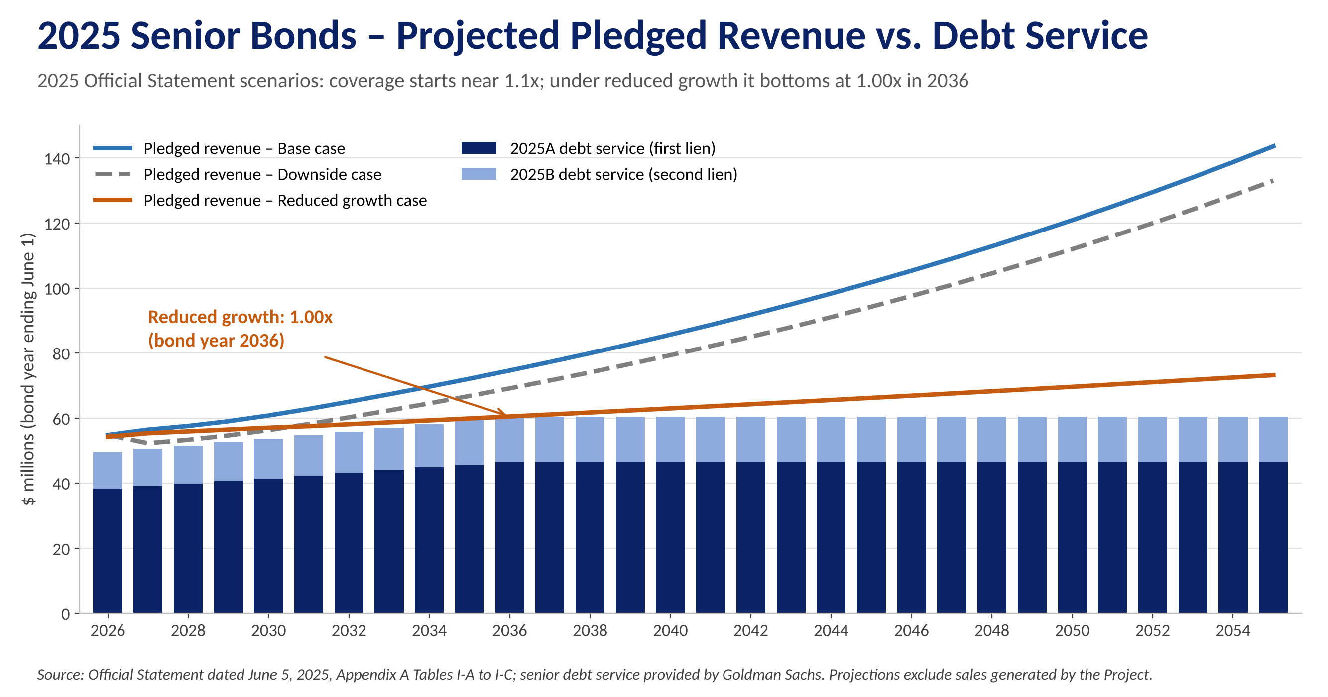
Figure C-1: 2025 senior bonds – projected pledged revenue versus debt service under the three Official Statement scenarios
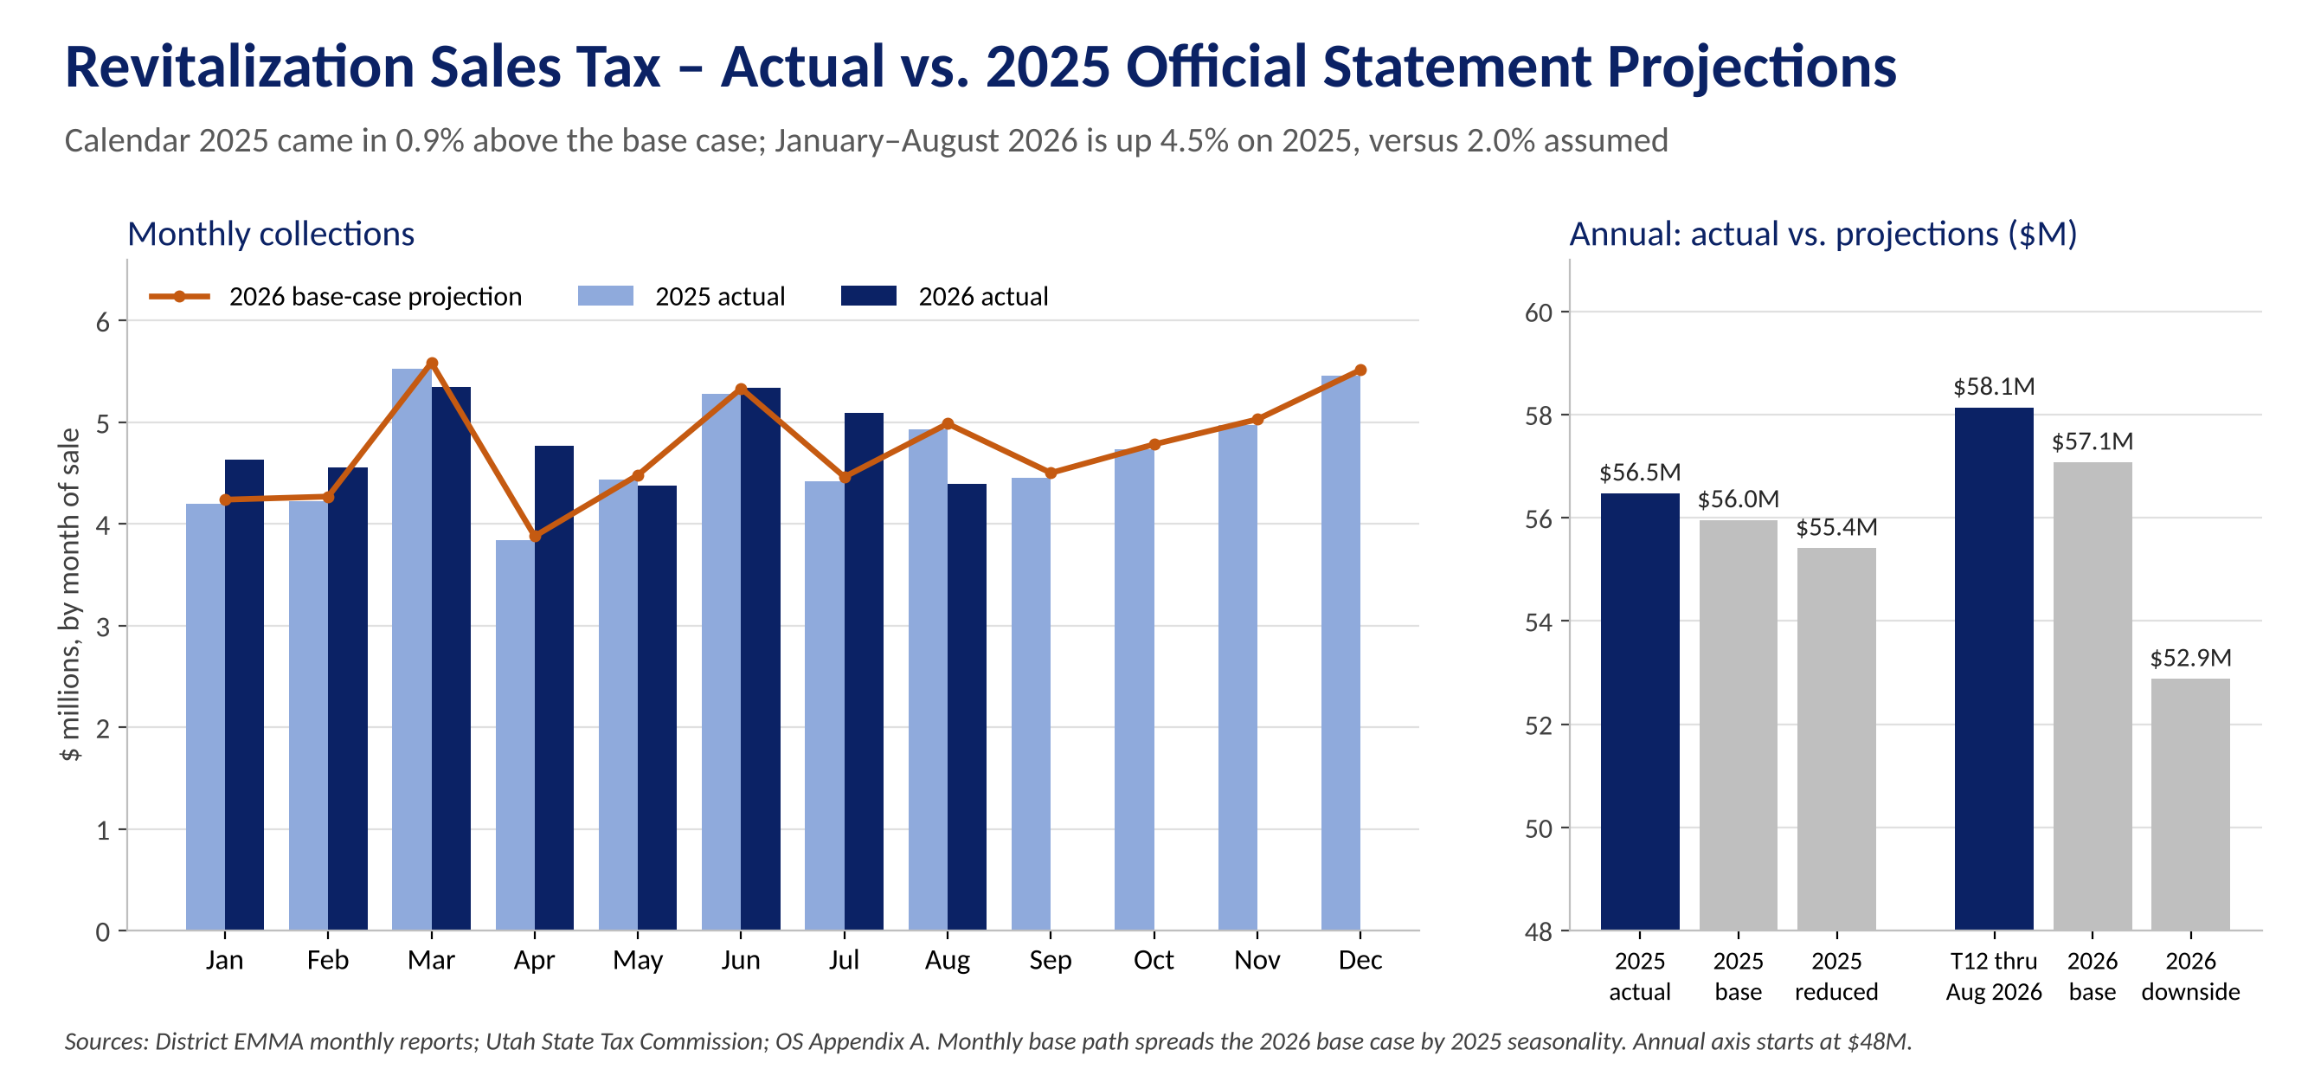
Figure C-2: Revitalization Sales Tax – actual collections vs. 2025 Official Statement projections
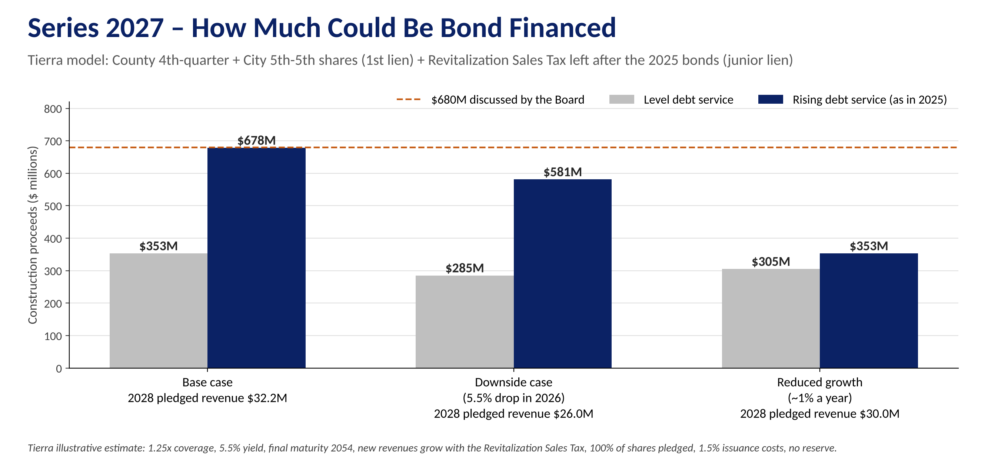
Figure C-3: Series 2027 – how much could be bond financed under the 2025 Official Statement's three cases (Tierra model)
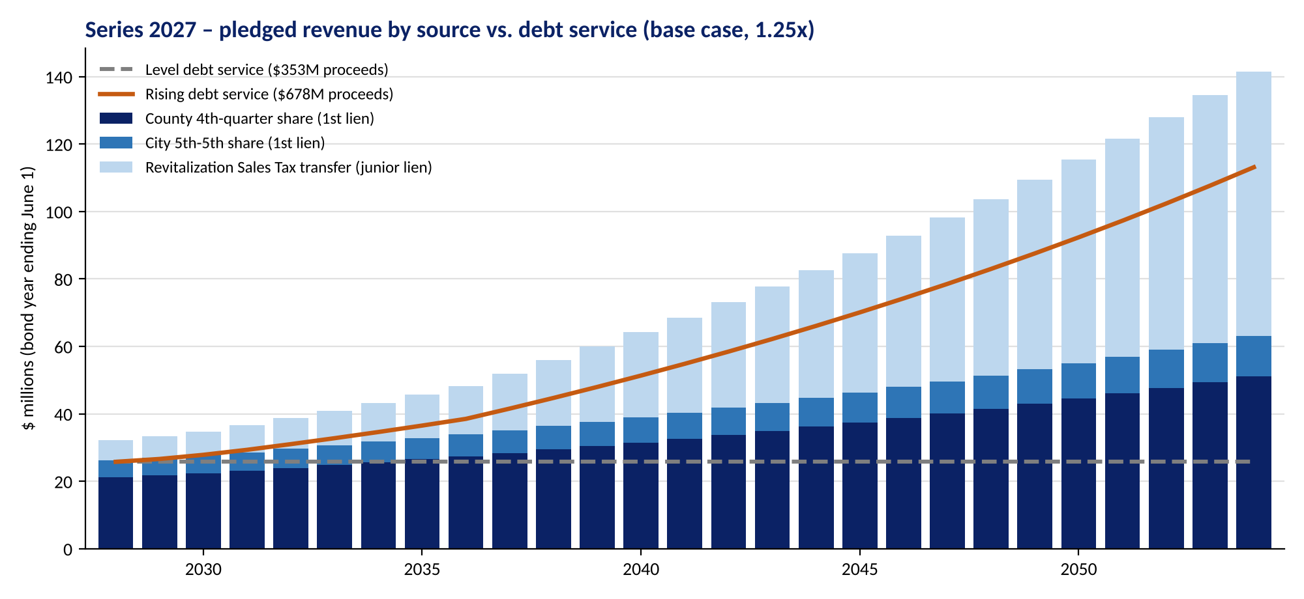
Figure C-4: Series 2027 – pledged revenue by source versus level and rising debt service, base case (Tierra model)
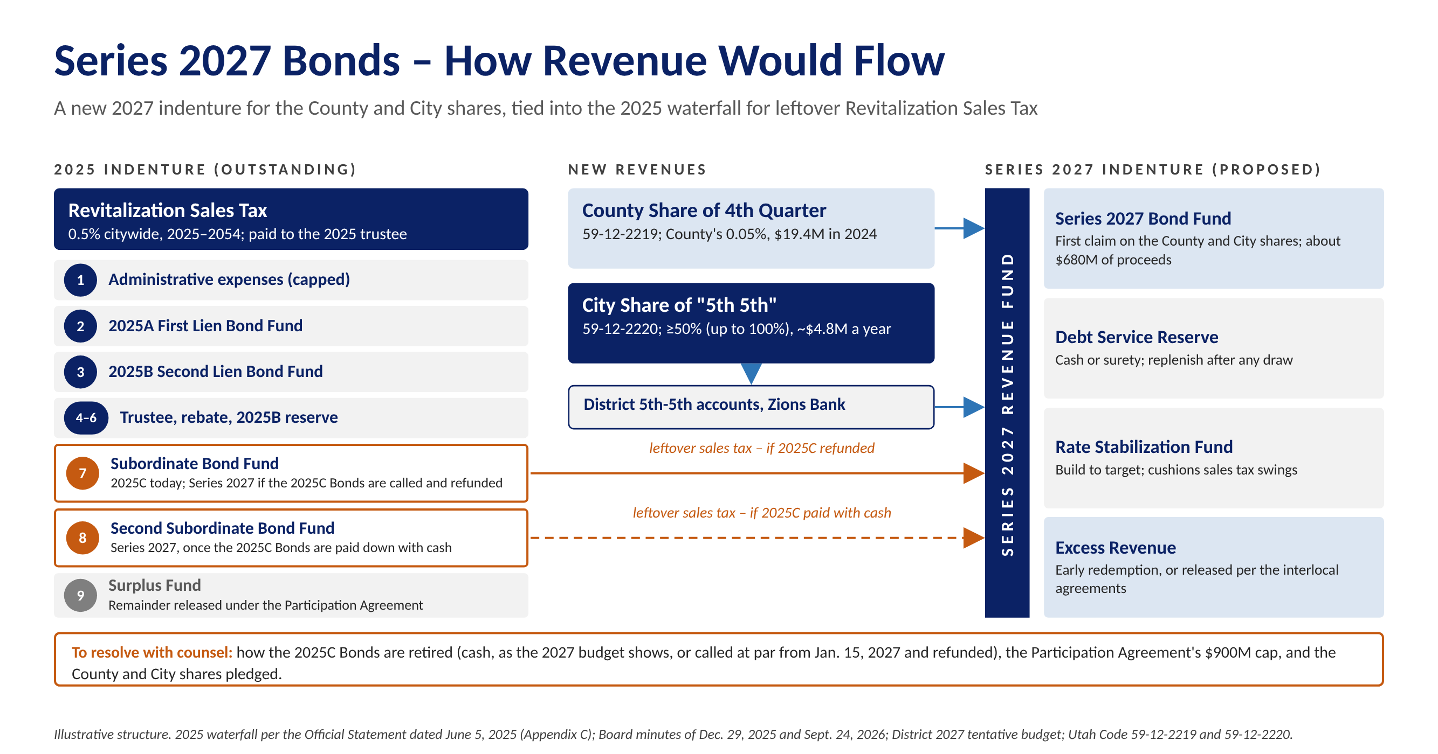
Figure C-5: Series 2027 Bonds – how revenue would flow (illustrative)
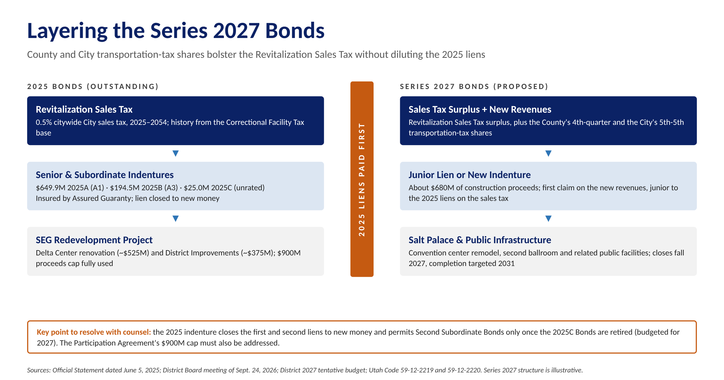
Figure C-6: Layering the Series 2027 Bonds beside the 2025 liens
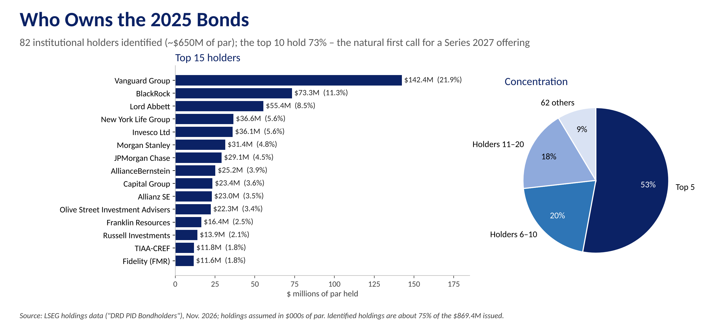
Figure C-7: Institutional holders of the 2025 Bonds

Appendix D – Series 2027 Preliminary Cash Flows
Output of Tierra's proprietary cash flow model for the District: a $680 million project fund financed with the same lien structure as the Series 2025 Bonds – Series 2027A first lien and 2027B second lien current interest bonds, and 2027C subordinate cash flow bonds paid from revenue left after senior debt service. Base case; bond years end June 1; cash flows in $ millions. [put more detail on the cashflow table below. Like the output models we talked about in pdf]
Sources | Amount | Uses | Amount
Series 2027A (first lien, 5.50%) | $352,625,000 | Project fund | $680,000,000
Series 2027B (second lien, 5.50%) | 98,735,000 | Underwriter's discount | 5,773,435
Series 2027C (cash flow, 7.00%) | 238,185,000 | Costs of issuance and rounding | 3,771,565
Total | $689,545,000 | Total | $689,545,000

Bond Year | 2027A DS | 2027B DS | Senior DS | County & City | Revit. Transfer | Total Pledged | 2027A Cov. | Senior Cov. | 2027C Paid | 2027C Balance
2028 | 20.13 | 5.64 | 25.77 | 26.24 | 5.97 | 32.21 | 1.60x | 1.25x | 6.44 | 249.13
2029 | 20.80 | 5.82 | 26.62 | 26.90 | 6.38 | 33.27 | 1.60x | 1.25x | 6.65 | 260.62
2030 | 21.75 | 6.09 | 27.85 | 27.70 | 7.10 | 34.80 | 1.60x | 1.25x | 6.96 | 272.59
2031 | 22.91 | 6.42 | 29.33 | 28.62 | 8.04 | 36.66 | 1.60x | 1.25x | 7.33 | 284.99
2032 | 24.23 | 6.79 | 31.02 | 29.62 | 9.14 | 38.77 | 1.60x | 1.25x | 7.75 | 297.81
2033 | 25.61 | 7.17 | 32.78 | 30.66 | 10.31 | 40.97 | 1.60x | 1.25x | 8.19 | 311.05
2034 | 27.04 | 7.57 | 34.61 | 31.74 | 11.53 | 43.26 | 1.60x | 1.25x | 8.65 | 324.74
2035 | 27.04 | 7.57 | 34.61 | 32.85 | 12.80 | 45.65 | 1.69x | 1.32x | 11.04 | 336.82
2036 | 27.04 | 7.57 | 34.62 | 34.00 | 14.14 | 48.14 | 1.78x | 1.39x | 13.53 | 347.10
2037 | 27.04 | 7.57 | 34.61 | 35.19 | 16.76 | 51.95 | 1.92x | 1.50x | 17.34 | 354.01
2038 | 27.04 | 7.57 | 34.61 | 36.42 | 19.47 | 55.89 | 2.07x | 1.61x | 21.28 | 357.19
2039 | 27.04 | 7.57 | 34.61 | 37.70 | 22.27 | 59.97 | 2.22x | 1.73x | 25.36 | 356.23
2040 | 27.04 | 7.57 | 34.61 | 39.02 | 25.17 | 64.19 | 2.37x | 1.85x | 29.58 | 350.68
2041 | 27.04 | 7.57 | 34.61 | 40.39 | 28.17 | 68.56 | 2.54x | 1.98x | 33.94 | 340.08
2042 | 27.04 | 7.57 | 34.61 | 41.80 | 31.28 | 73.08 | 2.70x | 2.11x | 38.47 | 323.89
2043 | 27.04 | 7.57 | 34.61 | 43.26 | 34.49 | 77.75 | 2.88x | 2.25x | 43.14 | 301.57
2044 | 27.04 | 7.57 | 34.61 | 44.78 | 37.82 | 82.60 | 3.05x | 2.39x | 47.99 | 272.50
2045 | 27.04 | 7.57 | 34.61 | 46.35 | 41.26 | 87.61 | 3.24x | 2.53x | 53.00 | 236.17
2046 | 27.04 | 7.57 | 34.61 | 47.97 | 44.83 | 92.80 | 3.43x | 2.68x | 58.19 | 194.51
2047 | 27.04 | 7.57 | 34.61 | 49.65 | 48.51 | 98.17 | 3.63x | 2.84x | 63.55 | 144.58
2048 | 27.04 | 7.57 | 34.61 | 51.39 | 52.34 | 103.73 | 3.84x | 3.00x | 69.12 | 85.58
2049 | 27.04 | 7.57 | 34.61 | 53.19 | 56.29 | 109.48 | 4.05x | 3.16x | 74.87 | 16.70
2050 | 27.04 | 7.57 | 34.61 | 55.05 | 60.38 | 115.43 | 4.27x | 3.34x | 17.87 | -
2051 | 27.04 | 7.57 | 34.61 | 56.98 | 64.61 | 121.59 | 4.50x | 3.51x | - | -
2052 | 27.04 | 7.57 | 34.61 | 58.98 | 69.00 | 127.97 | 4.73x | 3.70x | - | -
2053 | 27.04 | 7.57 | 34.61 | 61.04 | 73.53 | 134.58 | 4.98x | 3.89x | - | -
2054 | 27.01 | 7.55 | 34.56 | 63.18 | 78.23 | 141.41 | 5.24x | 4.09x | - | -
Total | 703.25 | 196.91 | 900.15 | 1,130.68 | 889.82 | 2,020.50 |  |  | 670.24
Senior debt service rises with pledged revenue at 1.25x (2027A 1.60x) through 2034 and is level after. Pledged revenue: County 4th-quarter and City 5th-5th shares (first lien, new indenture) and the Revitalization Sales Tax left after the 2025 Bonds (junior lien), 2025 Official Statement base case. 2027C balance includes accrued, compounding interest. No debt service reserve fund; costs at Series 2025 rates. Illustrative; full model available to the District.

